|  |  |
| --- | --- |
|  |  |
| How To Guide  SAP Business One Cloud  Document Version: 1.1 – 2019-01-01 | Public |
| Work with Tenant Configurator for SAP Business One Cloud  SAP Business One Cloud | |

SAPLogo.gifSee \\dwdf212\Info_Dev\KM_Layouts\LayoutSpecs\PDF_Documents\Final\DocuTemplateDOCX_instructions.pptx on how to use the template.

NOT INTENDED TO BE TRANSLATED.

Typographic Conventions

|  |  |
| --- | --- |
| Type Style | Description |
| Example | Words or characters quoted from the screen. These include field names, screen titles, pushbuttons labels, menu names, menu paths, and menu options.  Textual cross-references to other documents. |
| Example | Emphasized words or expressions. |
| EXAMPLE | Technical names of system objects. These include report names, program names, transaction codes, table names, and key concepts of a programming language when they are surrounded by body text, for example, SELECT and INCLUDE. |
| Example | Output on the screen. This includes file and directory names and their paths, messages, names of variables and parameters, source text, and names of installation, upgrade and database tools. |
| Example | Exact user entry. These are words or characters that you enter in the system exactly as they appear in the documentation. |
| <Example> | Variable user entry. Angle brackets indicate that you replace these words and characters with appropriate entries to make entries in the system. |
| EXAMPLE | Keys on the keyboard, for example, F2 or ENTER. |

Table of Contents

Contents

1 Introduction 4

2 Pre-requisite 5

2.1 Mandatory Steps 5

2.2 Optional Steps 5

3 Working with the solution: Step-by-Step 6

3.1 High Level Steps Review 6

3.2 Setup the Solution 6

4 Tenant Configuration 7

4.1 Entry point 7

4.2 Overview 7

4.3 Step-by-Step Guide for Tenant Configuration 8

5 Customer Configuration 12

5.1 General description 12

5.2 Entry point 12

5.3 Page Overview 14

5.4 On Boarding Process Example 15

6 Activity History Report 18

6.1 General description 18

6.2 Entry point 18

7 Customization 20

8 Appendix A 22

8.1 Tenant Configuration Fields 22

8.2 Customer Configuration Fields 23

9 Appendix B 25

10 Appendix C 27

# Introduction

With the ongoing growth of SAP Business One on the cloud, more and more partners seek a way to automate the process of tenant configuration and creation in order to streamline this process and avoid as much as manual work.

To answer this need, with the solution described in this document; the Tenant Configurator, SAP provides its partners a service to streamline this process on the cloud. The Tenant Configurator can be used for several cases, enabling partners to accelerate their volume business for **pre-configured** solutions:

* OEM Deals (e.g., a Bank is offering SAP Business One for its customers)
* Packaged solutions (e.g., Financial package or Starter Package)
* Vertical/Micro-vertical solutions (e.g., solution for the auto-motive industry)

One of the classic cases to illustrate the solution is OEM deals. For the sake of simplicity, this document explains the solution in the context of OEM but is not limited only to OEM.

In OEM use case, SAP sells an OEM party 1000’s seeds of SAP Business One and the OEM sell SAP Business One to its customers with a help of partner. For example, an OEM party can be a Bank, which will offer SAP Business One to its customers. In other words, the OEM party is a sales channel for SAP Business One.

In each such OEM deal, there are several parties:

* OEM – the company that partner with SAP
* Distributor Partner – a partner that helps the OEM to sell SAP Business One and responsible for the onboarding process of the customer
* Local Partners – this is optional. In some deals, there might also local partners that will support the customers.
* SAP – responsible for providing a provisioning component (Tenant configurator) to configure SAP Business One settings and creating a tenant for the customer. This component will be plugged-in in the distributor partner’s onboarding process as can be seen in the following diagram:

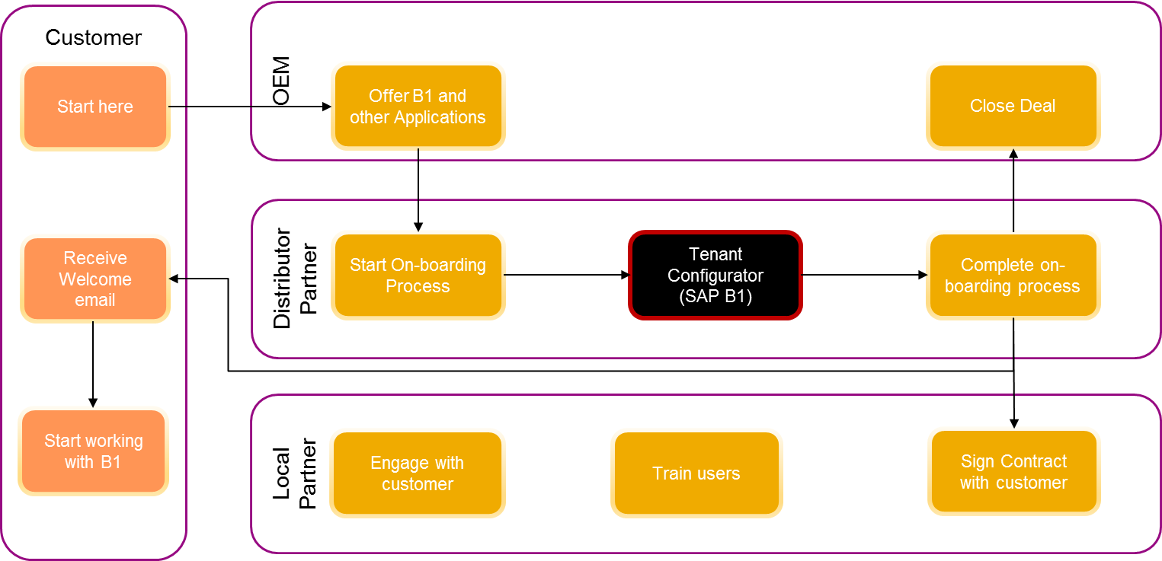

As can be seen from the business process, the OEM customer experience will be as followed:

* The OEM customer is offered with SAP Business One in the OEM web site
* from the OEM web site, the customer is redirected to your site to start the onboarding process, where part of this process is the Tenant Configurator service, provided by SAP.
* After the tenant is created, the customer completes the on-boarding process and finally the customer gets an email from you with a link to your cloud environment, so he can login and start to work.
* In parallel, the local partner starts to engage with the customer (support, train, etc.)

# Pre-requisite

## Mandatory Steps

1. Obtain an operating cloud environment and in particular, SLD is up and running (version PL 12 or lower). It can be either HANA or SQL cloud. The usage of CCC is not mandatory.
2. You have MS SQL server in your cloud environment. It can be the same SQL Server of the SLD DB or any other.
3. You have a web server on Windows machine, such as IIS or tomcat.
4. If you want to create a tenant out of HANA DB backup, you must upgrade to SAP Business One Cloud 1.1 PL11.
5. Configure the ‘mailer’ in the CCC or Gmail account in one authentication method (make sure you have one of these options).

## Optional Steps

* Define industry packages – this need be done as part of your on-boarding process
* Use a CRN (Customer reference number) to identify customers - this need be done as part of your on-boarding process
* Prepare a pre-configured company using DB backup or a package with the solution packager

# Working with the solution: Step-by-Step

## High Level Steps Review

1. Setup the solution – refer to section 3.2: Setting up the solution
2. Configure the tenant creation – refer to section 4: Tenant Configuration
3. Configure customer parameters – refer to section 5: Customer Configuration
4. View Activity History – refer to section 6: Activity History
5. If you want to customize the solution by adding more fields or changing its logic, refer to section 7 – Customizing the Solution

## Setup the Solution

1. After you’ve downloaded the Tenant Configurator package and unzipped it, there are 2 files in it: client-side (TC-Client.zip), server-side (TC-Server.zip) and node. js installation package.
2. Copy the zip files to a Windows server and unzip it on your file system: the server file (TC-server.zip) can be unzipped in any location on the file system, while the client file (TC-Client) need to be unzipped under your web server directory – in Windows IIS, unzip it under c:\inetpub\wwwroot. The Windows server can be any server in your cloud environment, such as the server where the SLD resides.
3. Install NodeJS on the same Windows server of the client and server files. You can download nodeJS in this link: [https://nodejs.org/en/download/releases](https://nodejs.org/en/download/releases/). The solution uses nodeJS version v9.2.1
4. Run the Tenant Configurator server – run the command line as administrator (use Windows cmd or PowerShell), navigate to the solution path you installed the server files and under TenantconfiguratorProject folder, type “node app”, followed by the ‘Enter’ key. For example, if you unzipped the server files under c:\Program Files, navigate in the command line (with the ‘cd’ command) to C: \ Program Files\TC- Server\TenantconfiguratorProject and type ‘node app’. If the server has loaded successfully, you should see a text on the screen: Running Server on port 3000. If you wish to change the port number, you can configure it in file app.js, line ‘*let port=3000*’.
5. Setup the client front-end: after you unzipped the client file (TC-Client.zip), you need to register the folder ‘TC-Client’ as a web site, with your web server (such as IIS or Tomcat) – refer to appendix B for more details how to do it in IIS.
6. 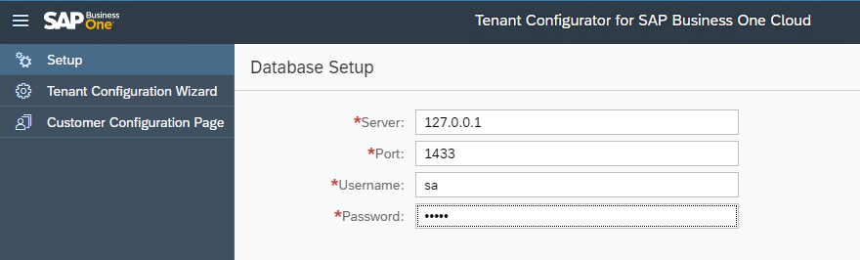Setup the solution DB: open the web page you registered in your web server in previous step – in the browser, type the URL with the port number you registered in your web server. For example, if you registered it in port 8080, the URL would look like this: <http://127.0.0.1:8080/TC-Partner>. Click the ‘Setup’ menu and enter your MS SQL server credentials (it can be any MS SQL server in your landscape). **Note**: Make sure that the user name you provide must be system administrator, with privileges to create databases and stored-procedures.
7. 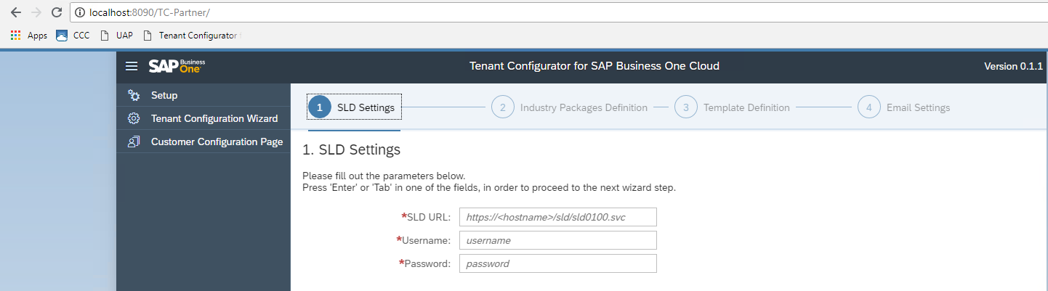Setup the SLD URL and credentials by clicking the button ‘Step 2' in previous step:

# Tenant Configuration

## Entry point

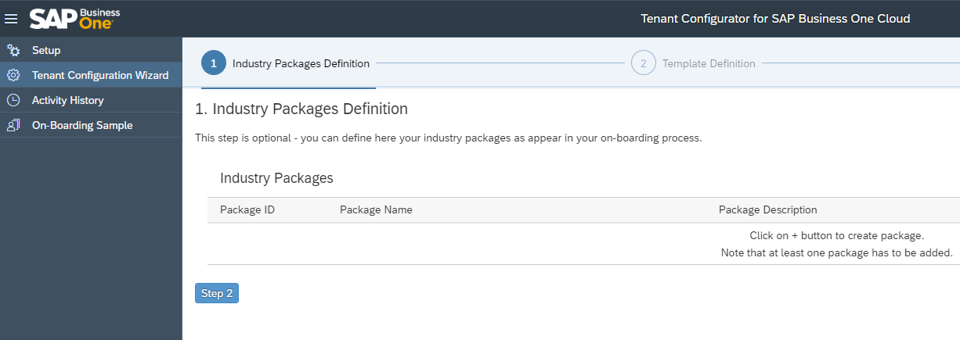The client web page that you registered in your web server (refer to 3.2) – in the browser, you need to type the URL with the port number you registered in your web server. For example, if you registered it in port 8080, the URL would look like this: <http://127.0.0.1:8080/TC-Partner>. In this landing page, press ‘Tenant Configuration Wizard’ menu on the left side:

## Overview

This is actually the essence of this solution – the main concept of this configurator is that it allows you to configure in only **one time** the various settings for creating a tenant (such as service unit, license, etc.) and once it is defined, any on-boarded customer request from the customer configuration page (as described in section 5), will use the settings defined here in order to create the tenant. In this way, you can automate and streamline the process of tenant creation without manual intervention.

You must define the settings defined in this section before receiving customer requests from the customer configuration page.

The following points describes the concept of this wizard:

* You can define several countries dynamically. Each country can have several unique industry packages associated with it. An industry package is an offering to your customers, i.e., basic package up to 5 users with limited functionality.
* The combination of country and package defines a **template**. For example, if you’re operating in Germany and you offer your customers 2 packages, Basic and Premium, you need to define 2 templates: one template will be Germany and Basic package and the second template will be Germany and Premium package.
  + Note that the package is not mandatory and if you’re not working with packages, you can leave this field empty. In this case, the country will have no package associated with it.
  + It is not possible to add a country with 2 of the same packages, nor a country with 2 empty packages.
  + Note: to work with industry packages, you must define it as part of your on-boarding process and use the same package IDs as in the Tenant Configurator.
* The company parameters (e.g., service unit) and license parameters are per template – this enables flexibility to manage your offering much better.
  + For example, it may be that the basic package will be on service unit A, using license file X and the premium package will be on service unit B, using license file B.
* In order to maximize your value from this wizard, you can pre-configure a company by using the Solution Package or a by preparing a DB backup and define it as the method to create the tenant in runtime.
  + Note that for HANA backup, you must use SAP Business One Cloud, PL 11.
  + For more details on how to work with backup and solution packages, refer to the latest **SAP Business One Cloud Administrator's Guide.**

## Step-by-Step Guide for Tenant Configuration

1. Open the tenant configuration wizard web page that you registered in your web server (as described in 3.2) – refer to ‘Entry Point’ above.
2. If you are working with packages in your on-boarding process, configure any type of packages you wish to introduce the customer to (this step is optional). For example, you can define 3 packages: Starter, Growth and Enterprise. This can be a great way to differentiate your customers – please see an example in section 5.5.
3. Define a template by clicking the + button on the right to open the template definition form – this is a mandatory step: you need to define at least one template in order to use the solution.
4. Fill out the details for the template you wish to create, such as service unit, license file, etc. – refer to the fields specification in the Appendix A

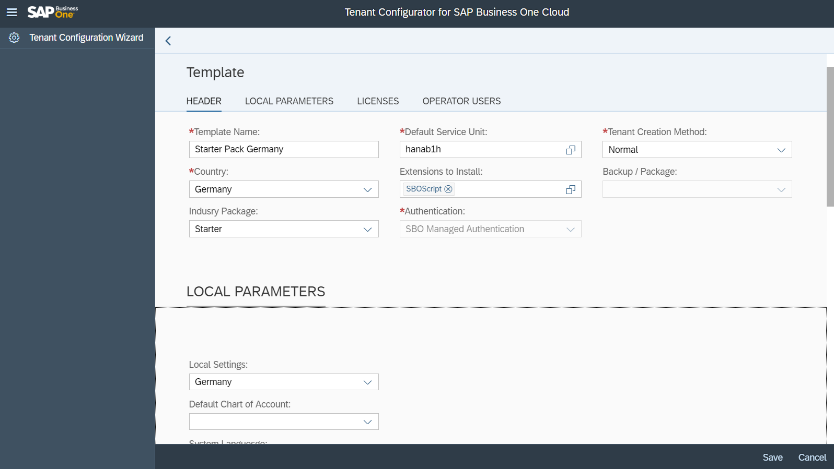

1. Please repeat the process until you create all your desired templates.
2. Configure the email server settings – either via CCC mailer or Gmail account. This will enable the solution to send you a notification email once a tenant is created in the system. If you’re using CCC mailer, make sure it’s configured properly.
3. The final step is to review the entire process and approve\modify changes if needed. You can either edit one or more of the stages or click submit. Once saved, you are ready now to start the on-boarding process of your customers (refer to section 5).

# Customer Configuration

## General description

This section describes the configuration that will be done by your customers, with the configuration page – this configuration page is part of this solution and normally, it should be embedded in your on-boarding process. The on-boarding process allows you to on-board your customers to your cloud, or the OEM customers (if you are a partner of OEM deals).

## Entry point

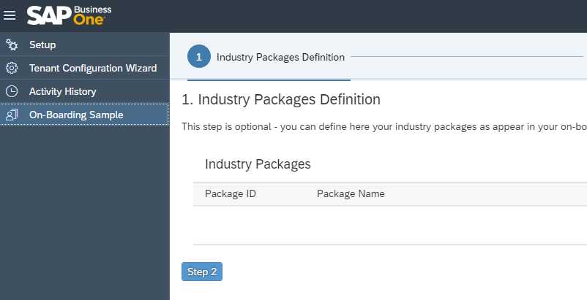In order to see this configuration page, we’ve provided you a sample for an on-boarding process. The sample can be accessed by clicking the ‘On-Boarding Sample’ menu:

This menu opens a sample for an on-boarding process:

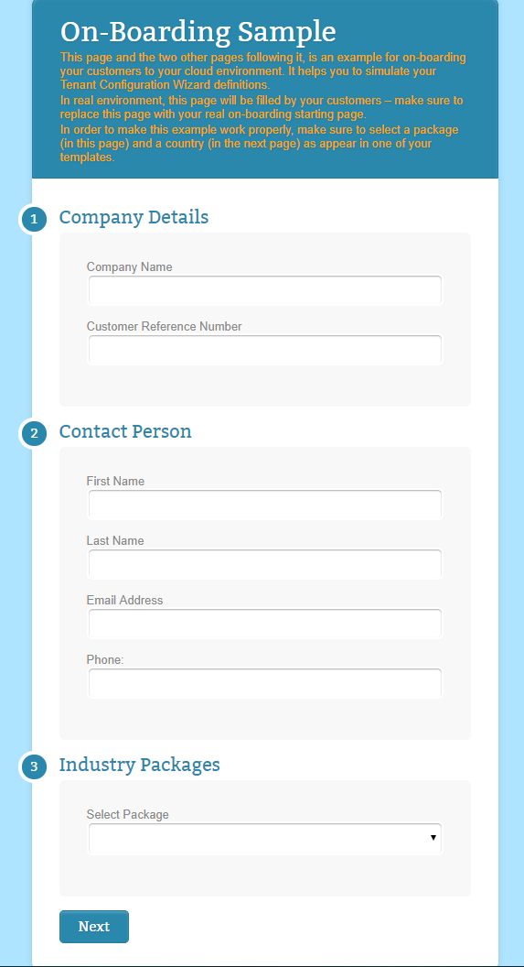

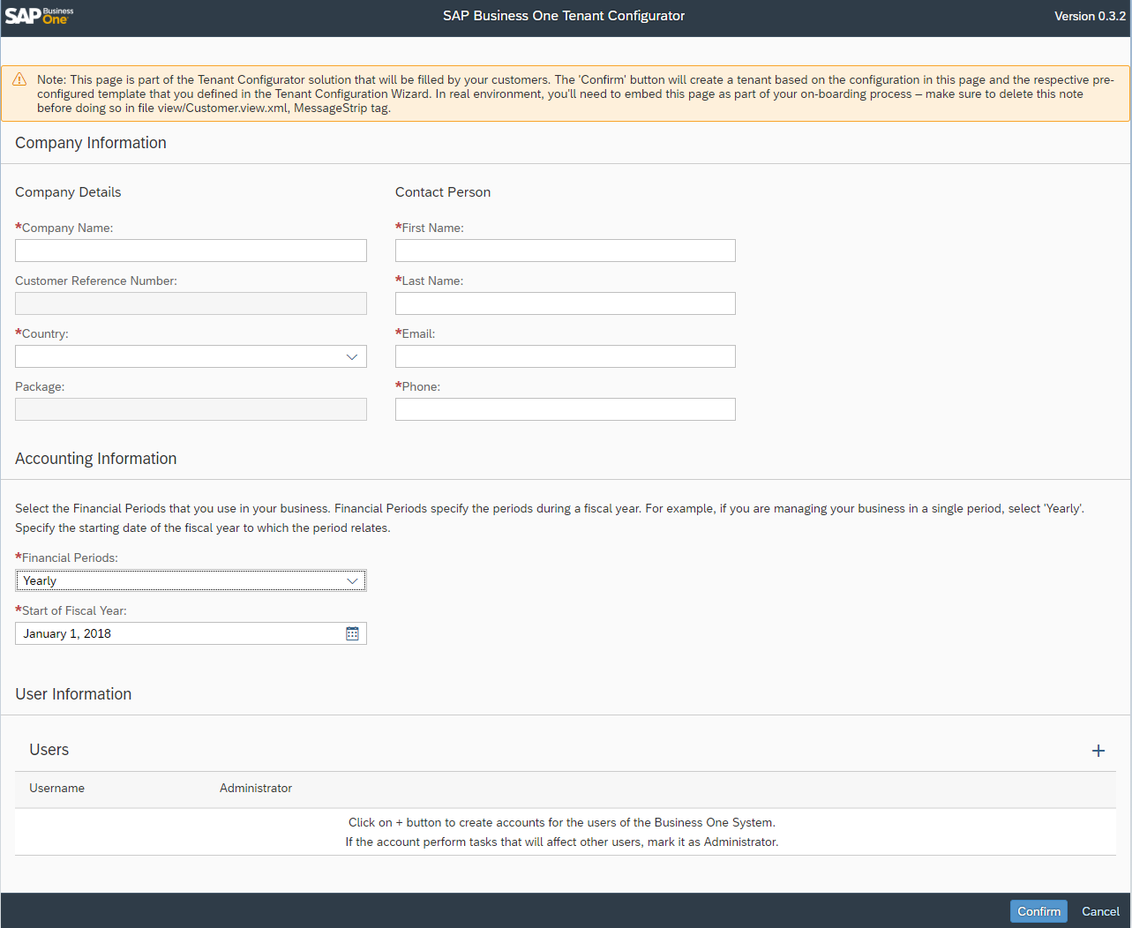You can fill all details in this sample page and when pressing the ‘Next’ button, it’ll open the customer configuration page:

For your internal testing purpses, you can simply fill all the paramters in this page and send to the server for creating the tenant.

In real life, this page normally will be a redirection from your onboarding process. This means that you’ll need to do few things:

* Make your on-boarding pages publicly accessible to your customers via your web server.
* Embed the customer configuration page in one of your on-boarding web pages. The location of this page (index.html) is under ‘TC-Customer’ folder, which is under the root folder ‘TC-Client’.
* Redirect the customer to complete the on-boarding process with your page – you can specify this page in the file \TC-Client\TC-Customer\model\Conf.json, under the key ‘nextPage’ (enter your URL page in this key).

Note: when you redirect the user to this page, you can include the following parameters in the URL, in this format <http://hostname?param1=paramvalue1&param2=paramvalue2> and so on, for each parameter:

|  |  |
| --- | --- |
| Parameter Syntax (case sensitive) | Description |
| cn | Company name |
| fn | First name |
| ln | Last name |
| e | Email |
| crn | Customer Reference Number |
| p | Industry Package – note that you need to provide its ID and not the name – you can see the ID of the corresponding name in the tenant configuration wizard (refer to section 4.3).  If you are not working with industry packages, don’t transfer this parameter in the URL or set it to 0 as the package ID |

For example, to pass CRN and package as parameters, the URL format will look like this: [*http://127.0.0.1?p=1&crn=123456*](http://127.0.0.1?p=1&crn=123456).

All these parameters are **optional**, so you can skip them if you don’t have this information from previous on-boarding pages.

To see another example of an on-boarding process, refer to section 5.4.

## Page Overview

* Posting periods -
  + Period number is derived from ‘Financial Periods’ user selection: 1 for Year, 4 for quarter and 12 for months.
  + End date is 12 months after the start date. For example, if start date is 1.1.18, end date is 31.12.18 and if start date is 1.4.18, end date will be 31.3.18.
* Users – It is possible to enter several users.
  + When users press the ‘Check code uniqueness’ button, the system would check whether this user exist in the cloud domain. If the user already exists, a message will alert the requestor.
  + If the Administrator checkbox is checked, when adding this user, it will be added as ‘power’ user.
  + All users are added with the password **Initial0**
* Upon sending all parameters to the server, it will create a tenant, based on the parameters in this page and the parameters that were defined in the tenant configuration wizard (refer to section 4). Few things to note:
  + The tenant is created as ‘Productive’ type.
  + At the end of the process of tenant creation, you’ll get a notification email with all details of the tenant creation.
  + The tenant creation process can take several minutes – until it completes, in order to check the tenant status, you can login to CCC and under ‘Tenants’ menu you should see a progress bar for the tenant creation.
  + If the tenant is not created or you don’t receive an email after 20 minutes, refer to Appendix C, troubleshooting.
* Upon receiving the notification email, you can contact your customer and provide him the login details to your system.

## On Boarding Process Example

Assume you’re an OEM partner for distributing SAP Business One with a Bank. This is an example of how your on-boarding process can look like – the first step offers your customers 3 packages that they can select:

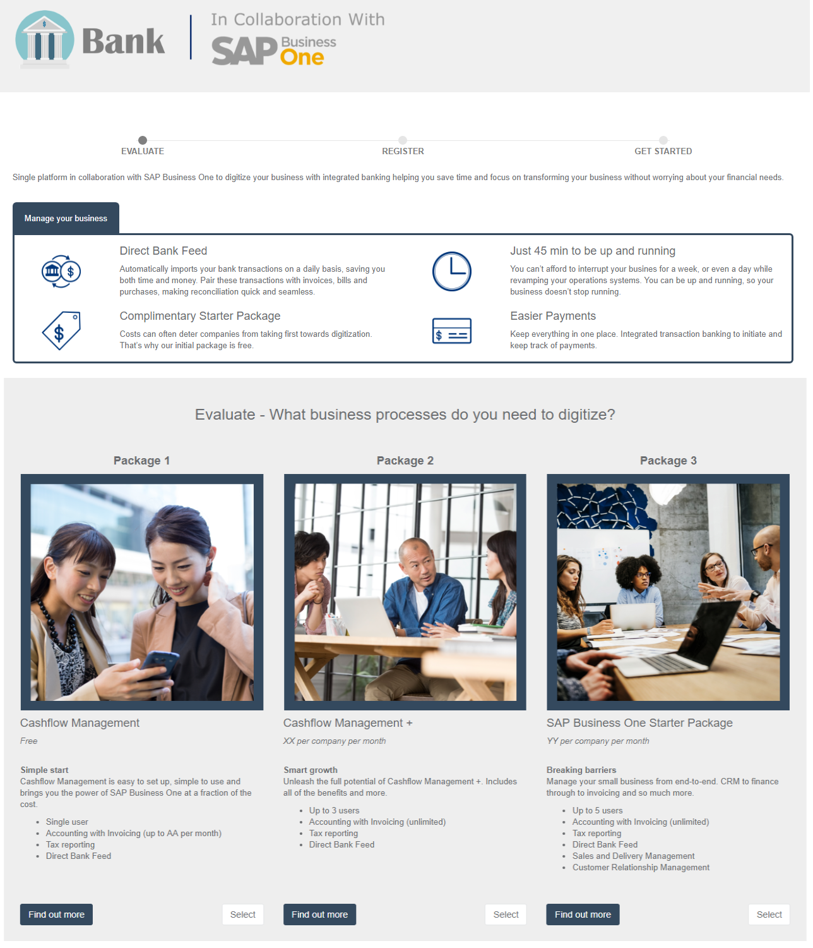

Once a package is selected, the second step is to fill some personal data:

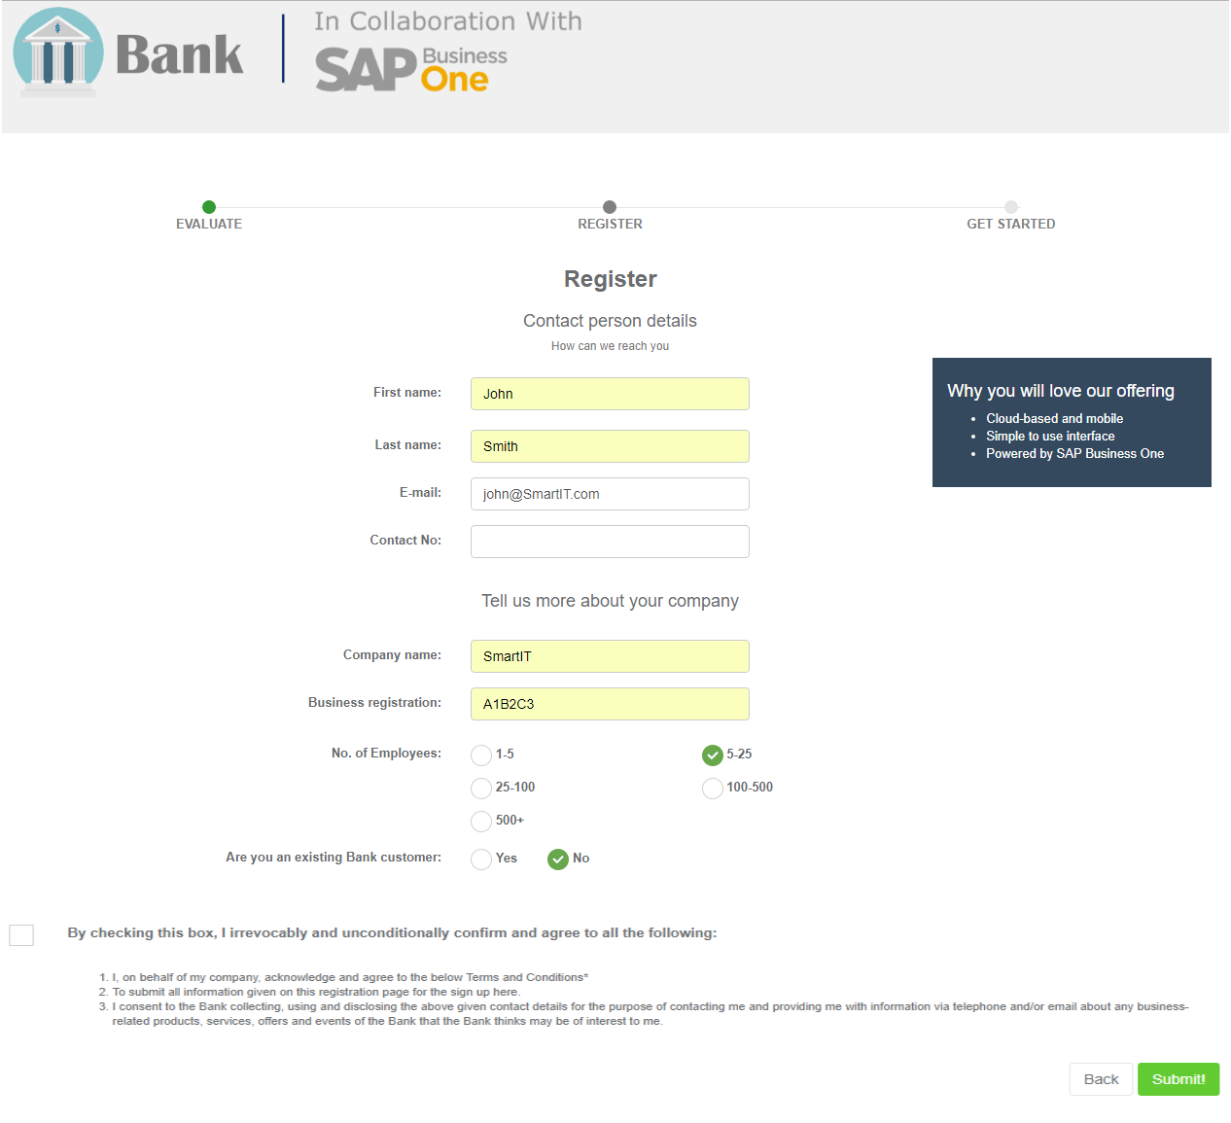

From this step, you can redirect your customers to the Configurator page, passing the personal data in the URL (package selected, company name, contact person details), which in turn, will be populated in the page:

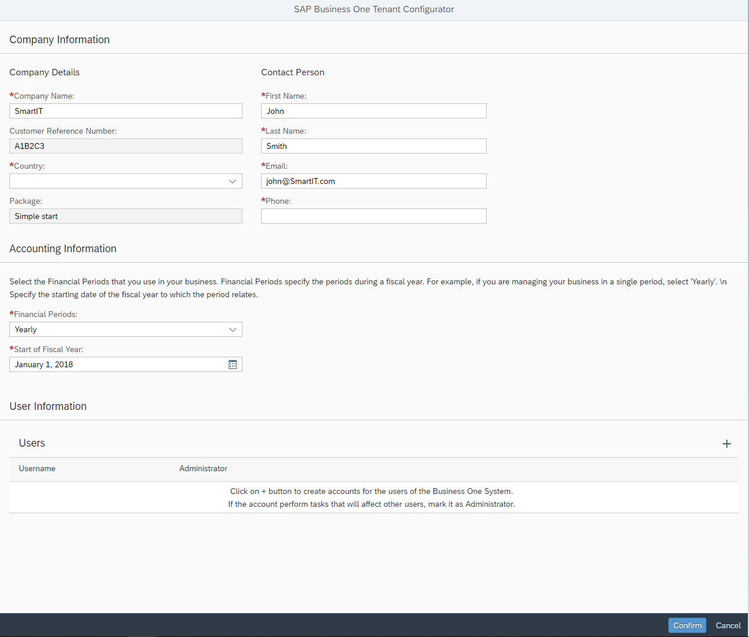

# Activity History Report

## General description

The Tenant Configurator keeps track of the activities in the system, Activity History can be used by you and SAP to track history and for troubleshooting.

Cloud Control Center (CCC) provides a task history, so you can either view it in the CCC, but in addition to that, you receive a more in-depth view with specific data from the Tenant Configurator. This activity history presents all your customer requests as were arrived from the customer configuration page, their details and status (completed, failed, etc.).

## Entry point

Press the ‘Activity History’ menu:

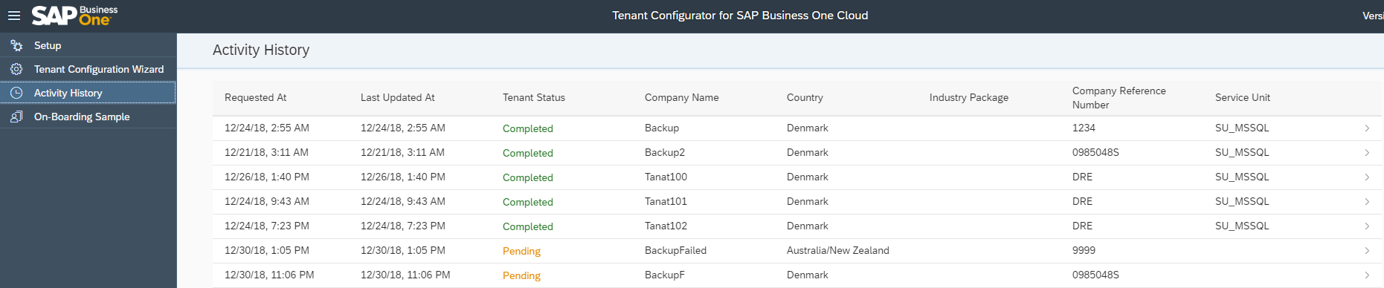

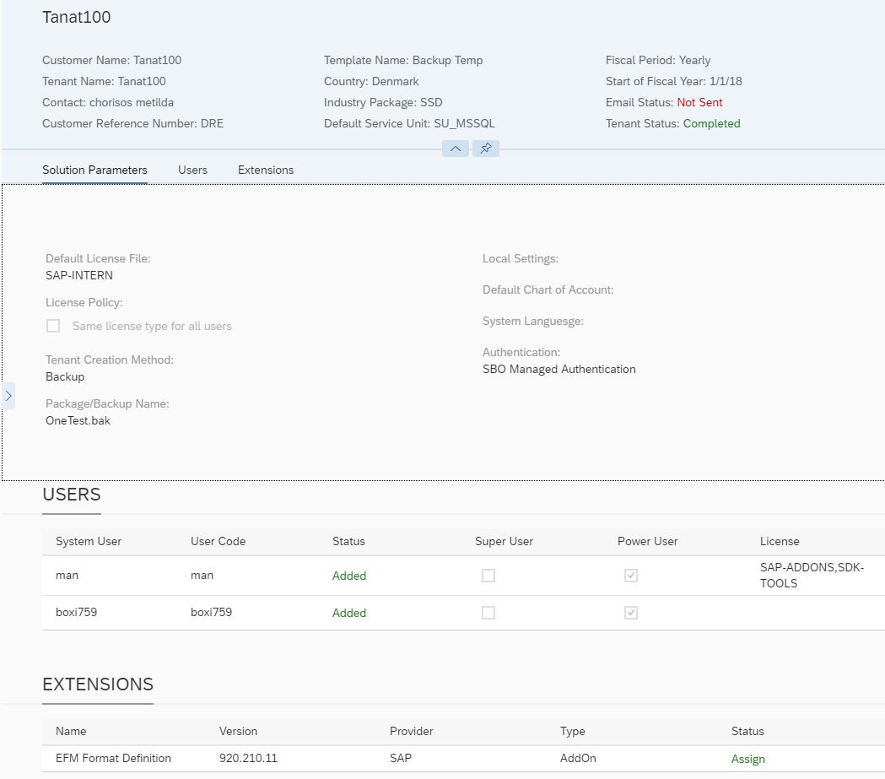Clicking a row, will open a detailed view:

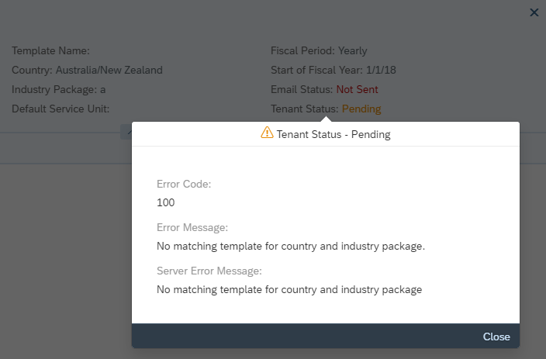Clicking the colored ‘Status’ filed will pop-up the error description so you can troubleshoot any errors if occurred:

# Customization

You can customize the Tenant Configurator to your own needs, such as adding fields to the tenant creation wizard and/or to the customer configuration page.

In order to do that, you need to be familiar with Fiori and node.js technologies.

In order to work with Fiori, you can refer to the following links:

<https://ux.wdf.sap.corp/fiori-design-web/>

<https://sapui5.hana.ondemand.com/>

To work with node.js, you can refer to <https://www.w3schools.com/nodejs/>

Naturally, if you add fields, you need to add it in 3 levels: GUI, DB and the server business logic.

The following diagram describes the architecture of the solution:

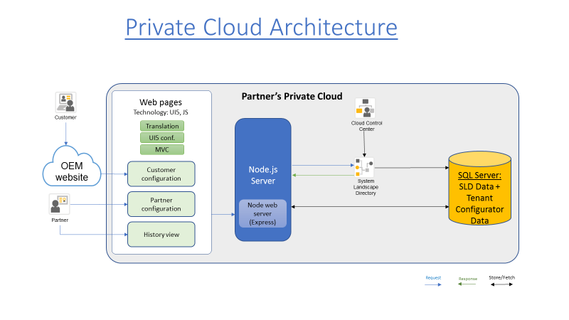

As can be seen from the diagram, the solution is composed from a front-end Java script GUI, based on Fiori, SAPUI5 and a back-end, based on Node .js. The data can be stored on any SQL Server you have. In order not to increase the TCO with a new DB server, you can store it on the same SQL server of the SLD, as illustrated in the diagram,

The following diagram illustrated the back-end server modules design:

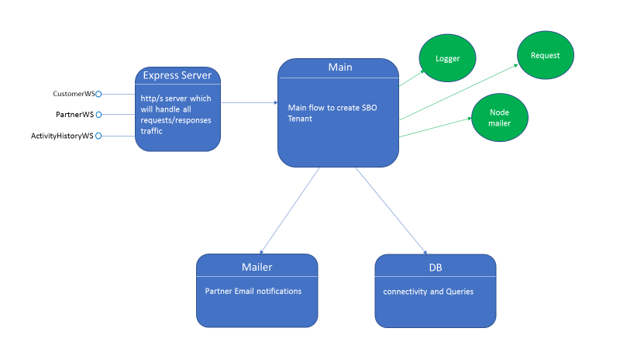

As can be seen from the diagram, the server exposes 3 interfaces to the front-end client: one for the customer configuration page, one for the tenant configuration wizard and another for the activity history – each interface has several methods in it that servers the relevant client page.

All client requests are processed by the Express module of node .js, which routes the specific http requests to the relevant module in the server.

The main module is called ‘Main’ which deals with the tenant creation. It uses node .js components (in green color).

# Appendix A

## Tenant Configuration Fields

|  |  |  |
| --- | --- | --- |
| Field | Type | Values |
| Cloud Paraments* | | |
| SLD URL and credentials (user name and password)* | URL |  |
| Domain Account name* | String (read-only) |  |
| Reseller ID* - only for public cloud* | List of values | The field is shown only if there are more than one reseller to display. |
| Package Paraments – this is an optional configuration that represents product package as offered to the customer in the on-boarding process | | |
| Package ID | Number | Internal ID for the package – use it when redirecting the user to the customer configuration page |
| Package Name* | String | Alphanumeric |
| Package Description | String | Alphanumeric |
| Company Parameters* – the following fields are per record when adding a new country. | | |
| Country* | List of values | SAP Business One supported countries |
| Package Name | List of values |  |
| Service Unit* | List of values |  |
| Company creation method* | Radio button | (1) Normal  (2) From Backup  (3) From Solution Packager |
| Authentication method* | List of values | For HANA, it’s always SBO and for SQL, it’s either Windows SSO or SBO |
| DB backup/Solution Package * | String | Alphanumeric.  This field depends on service unit selection.  This field is editable only if company creation method is from backup or solution packager. |
| Extensions to install | List of values | This field depends on service unit selection. |
| Company Local Settings Parameters – the following fields should be enabled only if company creation method is ‘Normal’ | | |
| Local Settings* | List of values | Localization |
| Chart of Accounts* | List of values | The COA templates of the selected localization |
| Base Language* | List of values | Default languages for default values |
| License Parameters - the following fields are per country-package pair | | |
| License file* | List of values | The License file to be used for the customer |
| License Policy* | Checkbox | (1) “All users are assigned with the same license type”  (2) “Different users have different license types” |
| License Type | List of values | Professional, Limited CRM, Limited Logistics, Limited Financials, Starter Package  This field would be open for selection only if License Policy is checked to (1) |
| Add operator users to tenant | List of values | Determine whether to add operator users to the created tenant |
| License Type for resellers | List of values | Professional, Limited CRM, Limited Logistics, Limited Financials, Starter Package  This field would be open for selection only if operator users were added to the tenant |
| Email Parameters* | | |
| Email Server* | Radio button | (1) “Use the Email Server defined in Cloud Control Center”  (2) “Use Gmail Email Server” |
| Email Parameters: user name, password,* | Stings | This field would be editable only if Email Server is (2) |
| Send Email to* | Email | Can be more than one address, separated with comma (,) |

* Mandatory field

## Customer Configuration Fields

The following fields would be displayed:

|  |  |  |
| --- | --- | --- |
| Field | Type | Valid Values |
| Company Information (sub title for the following fields) | | |
| Company name* | String | Alphanumeric. |
| Country* | List of values | Supported countries of the solution |
| Customer Reference Number | String | Read-only  Would be transferred in URL from the previous on-boarding process step. |
| Industry Package ID | String | Read-only  Would be transferred in URL from the previous on-boarding process step. |
| Contact Person (sub title for the following fields) | | |
| Name* | Number | Alphanumeric. |
| Phone* | Number | Numeric. |
| Email* | String | Alphanumeric. |
| Accounting Information (sub title for the following fields) | | |
| Financial Periods* | List of values | Yearly, Quarterly, Monthly |
| Period Starts* | Date picker | Dates |
| Users Information (sub title for the following fields) | | |
| User name* | String | Alphanumeric |
| Administrator* | Checkbox | Yes/No |

* field is mandatory

# Appendix B

This section describes how to add a web site with the IIS in Windows.

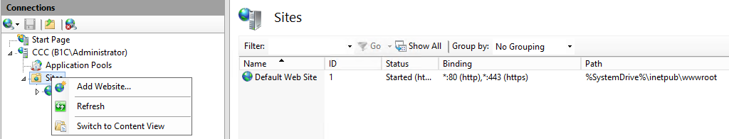Open the IIS and right click the ‘Sites’ menu – select ‘Add Website’ menu:

In the opened dialog, select the physical path folder you want to publish under c:\inetpub\wwwroot folder. To publish the Tenant Configurator landing page, select ‘TC-Client’ folder:

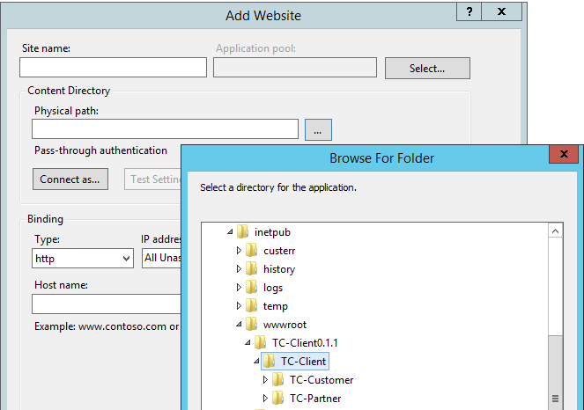

Fill the Site name with any given name you like and select a free port:

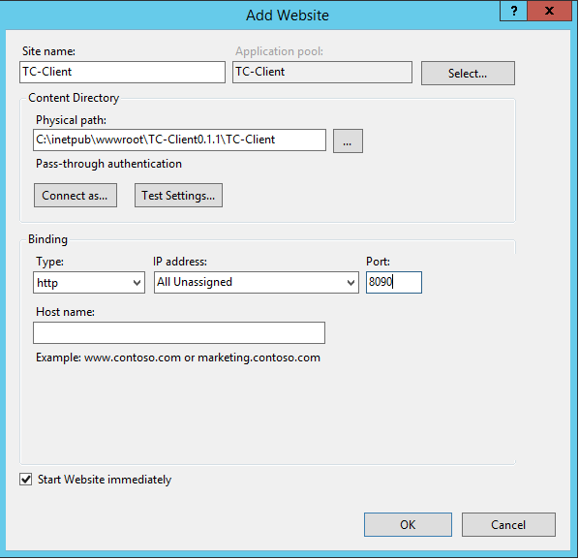

**Note**: do **not** try to open the web site via the IIS (by using ‘Browse Website’ Action) since it’ll not be opened, as it has 2 sub folders under it. In order to open the web site, you need to open it via the browser (refer to section 3.2 or 4.1 for the URL).

# Appendix C

The following points describes various troubleshooting you can encounter when working with the Tenant Configurator.

The Tenant Configurator landing page is not displayed in the browser – check the following:

* The physical path in IIS registration should be TC-Customer and **not** TC-Partner
* You type the correct URL, with the port you’ve registered and you include the string ‘TC-Partner’ in the URL: <http://localhost:port/TC-Partner>

You don’t receive a notification email upon tenant processing – possible reasons:

* If you’re using the CCC mailer, it might be not configured properly
* If you’re using the Gmail account, it might be configured with a 2-way authentication (email and phone). The node.js supports only one-way authentication method.
* The Tenant Configurator server could not find a matching template of the given country and industry package – in this case, no email is sent.

The ‘Step 2’ button does not appear in the first wizard step – possible reasons:

* You need to press the Enter key or Tab key in one of the field in order to proceed with the wizard
* One of the SLD parameters is wrong. Note that the wizard checks if there is connection and if there is no connection, the button is disabled.
* For the very first time you work with the system, sometimes, it takes few seconds to retrieve data from the SLD after the login to the SLD is successful. Once all data is retrieved, you can proceed to the next step.

|  |
| --- |
|  |
| www.sap.com/contactsap |
| Material Number  © 2018 SAP SE. All rights reserved.  No part of this publication may be reproduced or transmitted in any form or for any purpose without the express permission of SAP AG. The information contained herein may be changed without prior notice.  Some software products marketed by SAP AG and its distributors contain proprietary software components of other software vendors.  Microsoft, Windows, Excel, Outlook, and PowerPoint are registered trademarks of Microsoft Corporation.  IBM, DB2, DB2 Universal Database, System ads, System i5, System p, System p5, System x, System z, System z10, System z9, z10, z9, iSeries, pSeries, xSeries, zSeries, eServer, z/VM, z/OS, i5/OS, S/390, OS/390, OS/400, AS/400, S/390 Parallel Enterprise Server, PowerVM, Power Architecture, POWER6+, POWER6, POWER5+, POWER5, POWER, OpenPower, PowerPC, BatchPipes, BladeCenter, System Storage, GPFS, HACMP, RETAIN, DB2 Connect, RACF, Redbooks, OS/2, Parallel Sysplex, MVS/ESA, AIX, Intelligent Miner, WebSphere, Netfinity, Tivoli and Informix are trademarks or registered trademarks of IBM Corporation.  Linux is the registered trademark of Linus Torvalds in the U.S. and other countries.  Adobe, the Adobe logo, Acrobat, PostScript, and Reader are either trademarks or registered trademarks of Adobe Systems Incorporated in the United States and/or other countries.  Oracle is a registered trademark of Oracle Corporation.  UNIX, X/Open, OSF/1, and Motif are registered trademarks of the Open Group.  Citrix, ICA, Program Neighborhood, MetaFrame, WinFrame, VideoFrame, and MultiWin are trademarks or registered trademarks of Citrix Systems, Inc.  HTML, XML, XHTML and W3C are trademarks or registered trademarks of W3C®, World Wide Web Consortium, Massachusetts Institute of Technology.  Java is a registered trademark of Sun Microsystems, Inc.  JavaScript is a registered trademark of Sun Microsystems, Inc., used under license for technology invented and implemented by Netscape.  SAP, R/3, xApps, xApp, SAP NetWeaver, Duet, PartnerEdge, ByDesign, SAP Business ByDesign, and other SAP products and services mentioned herein as well as their respective logos are trademarks or registered trademarks of SAP AG in Germany and in several other countries all over the world. All other product and service names mentioned are the trademarks of their respective companies. Data contained in this document serves informational purposes only. National product specifications may vary.  These materials are subject to change without notice. These materials are provided by SAP AG and its affiliated companies ("SAP Group") for informational purposes only, without representation or warranty of any kind, and SAP Group shall not be liable for errors or omissions with respect to the materials. The only warranties for SAP Group products and services are those that are set forth in the express warranty statements accompanying such products and services, if any. Nothing herein should be construed as constituting an additional warranty. |

SAPLogo.gif